

Experiment No.: 07
Title: Integrate Kubernetes and Docker

Batch: B–1 Roll No.: 16010422234 Experiment No.: 07
_____________________________________________________________________________

Aim: To create Docker image using Dockerfile for NodeJS application, run and Push it on DockerHub.
_____________________________________________________________________________

Resources needed: Docker Hub Account, Kubernetes
_____________________________________________________________________________

Theory:

Kubernetes and Docker are both popular technologies for managing containers, but they are used for different purposes. Kubernetes is an orchestration platform that provides a higher-level abstraction for managing containers, while Docker is a containerization technology that provides a lower-level runtime for containers. To integrate Kubernetes and Docker, you need to use Docker to build and package your application as a container image, and then use Kubernetes to manage and orchestrate the containers.

Docker is an OS-level virtualization software platform that helps users in building and managing applications in the Docker environment with all its library dependencies.

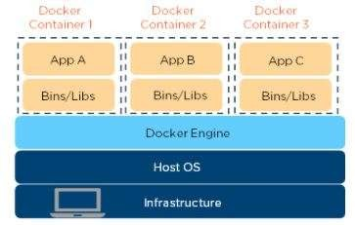

Docker image is a read-only, inert template that comes with instructions. In Docker, everything basically revolves around images. An image consists of a collection of files (or layers) that pack together all the necessities—such as dependencies, source code, and libraries—needed to set up a completely functional container environment. Images are stored on a Docker registry, such as the Docker Hub, or on a local registry.

Docker Container is a lightweight software package that includes all the dependencies (frameworks, libraries, etc.) required to execute an application. The running image is the container.

Dockerfile is a simple text file that consists of instructions to build Docker images. Dockerfile is used to create Docker images. Dockerfile is nothing but a blueprint for the image. All the Docker images have Dockerfile. Dockerfile consists of specific commands that guide you on how to build a specific Docker image.

The specific commands you can use in a dockerfile are: FROM, PULL, RUN, and CMD
FROM - Creates a layer from the ubuntu:18.04
PULL - Adds files from your Docker repository
RUN - Builds your container
CMD - Specifies what command to run within the container

Create a Docker image using two methods:
- Develop all the code locally(on your local computer). And package all the code as Docker image using Dockerfile.
- Run Docker container. Then place all your code inside the Docker container(Enter into docker container using docker exec command). And build an image using the running Docker container.

The below diagram is a Dockerfile example for the NodeJS application:
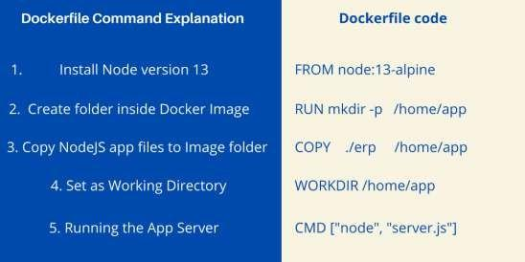
_____________________________________________________________________________

Procedure:
- Create an Account on Docker Hub.
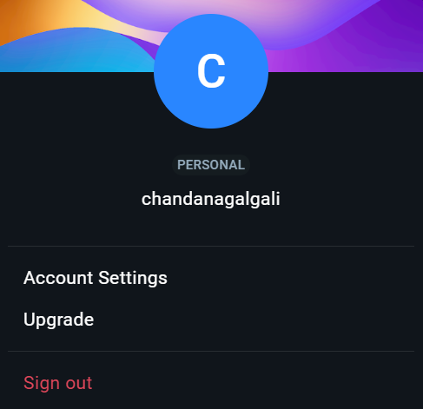
- Install Docker and explore Docker commands.
- Write a NodeJS Application.
- Write a Dockerfile for NodeJS Application.
- Create/build an image and check for its availability in the local computer.
- Run the created image.
- Push the image on Docker Hub.
- Use Kubernetes to deploy the Docker image to a cluster
  - Create a deployment
  - Create a service
- Modify the code, create/build and run the updated image
_____________________________________________________________________________

Results: (Document with screenshots)
- NodeJS Application code
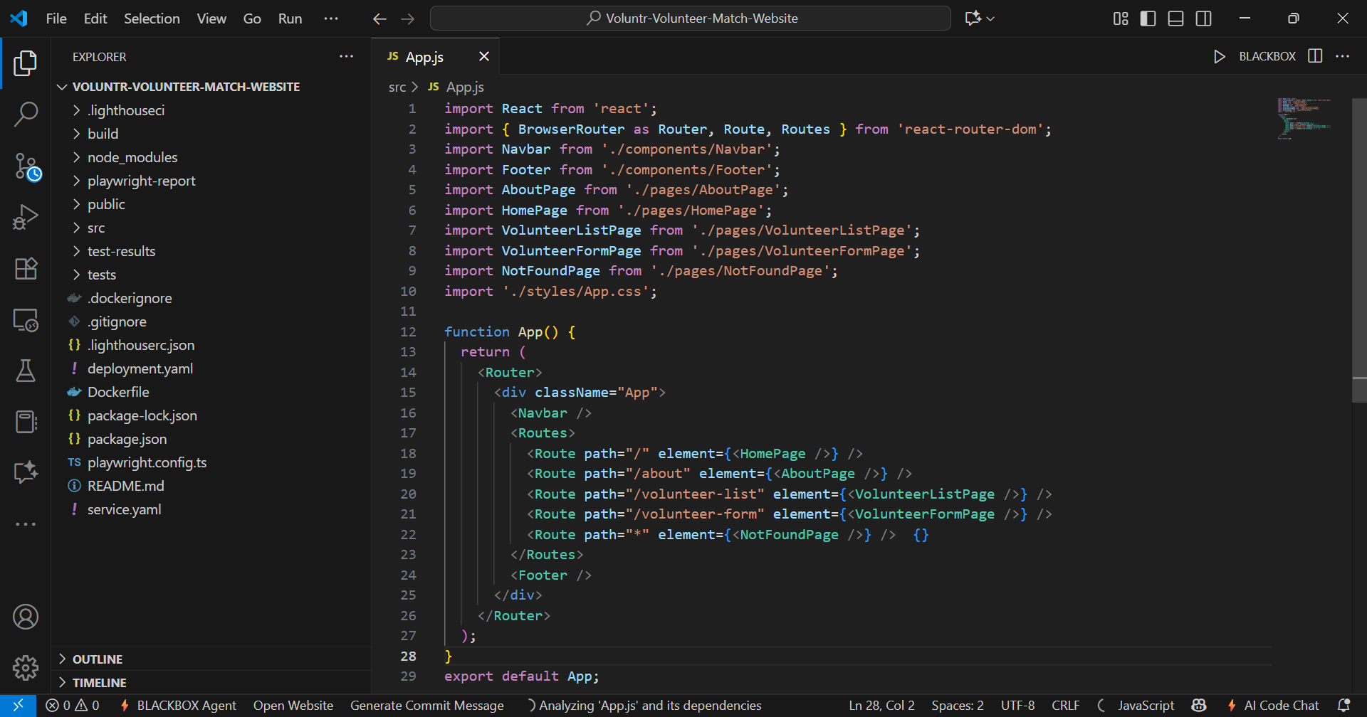
- Dockerfile content.
# Stage 1: Build the React application for production
# We use a Node.js image to have access to npm and build tools.
FROM node:18-alpine AS builder

# Set the working directory inside the container
WORKDIR /app

# Copy the package.json and package-lock.json files
COPY ./package.json ./
COPY ./package-lock.json ./

# Install the dependencies
RUN npm install

# Copy the rest of the application source code
COPY . .

# Build the app for production
# This command is specified in your package.json scripts
RUN npm run build

# Stage 2: Serve the production build with NGINX
# We use a very lightweight NGINX image to serve the static files.
FROM nginx:stable-alpine

# Copy the built files from the 'builder' stage to NGINX's public directory
# The 'build' directory is where 'npm run build' outputs the static files
COPY --from=builder /app/build /usr/share/nginx/html

# Expose port 80 to the outside world
EXPOSE 80

# The default NGINX command runs, which serves the content
CMD ["nginx", "-g", "daemon off;"]
- Commands with output
  - Create image
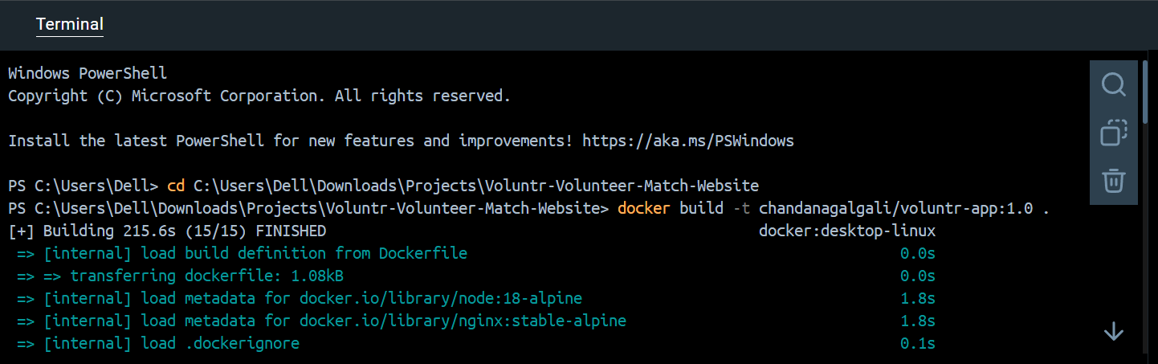
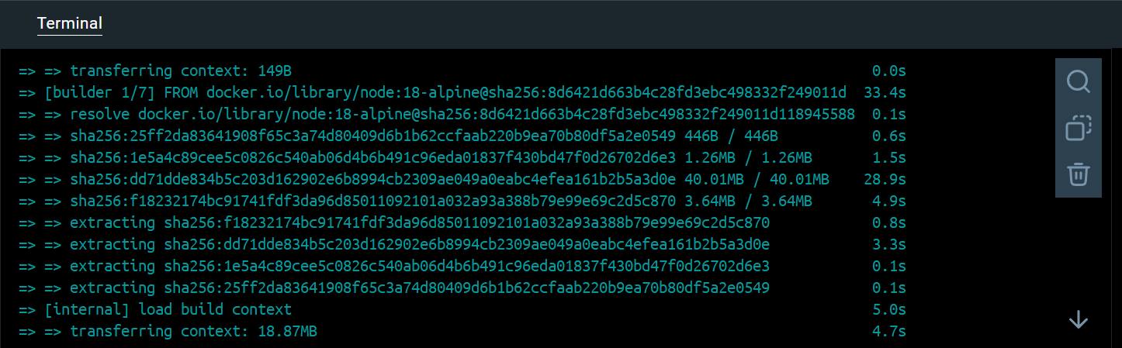
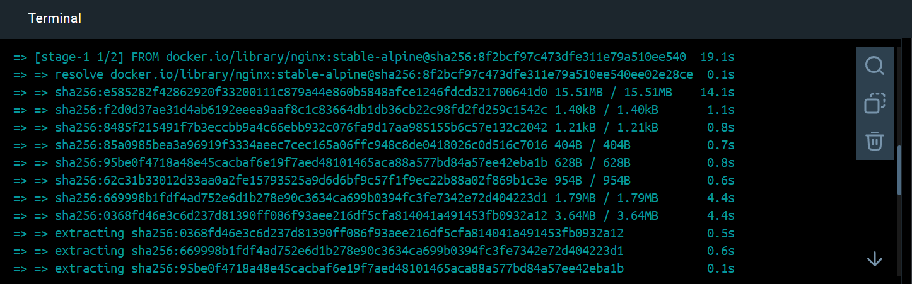
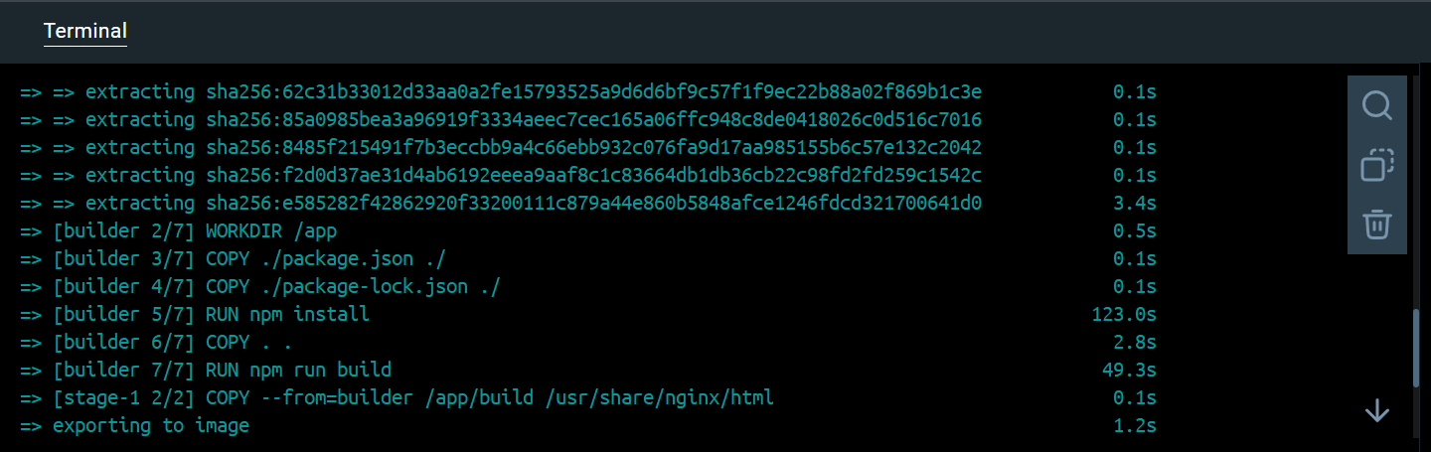
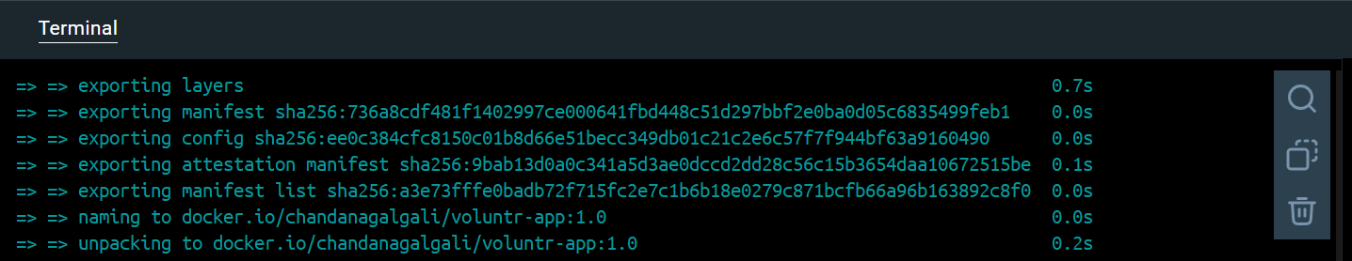
  - Check for its availability on the local computer.
  - Run the created image.
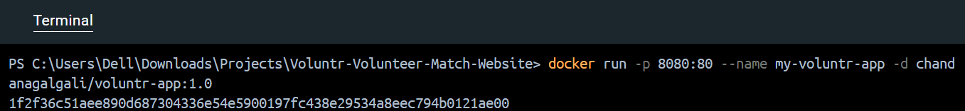
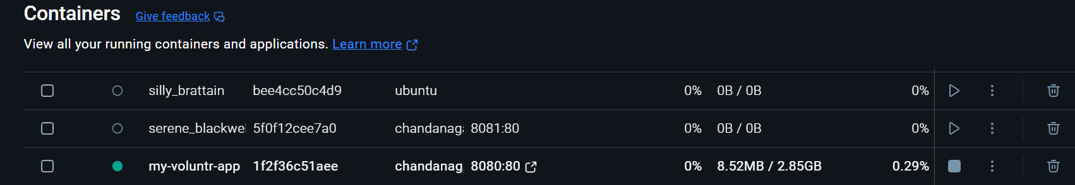
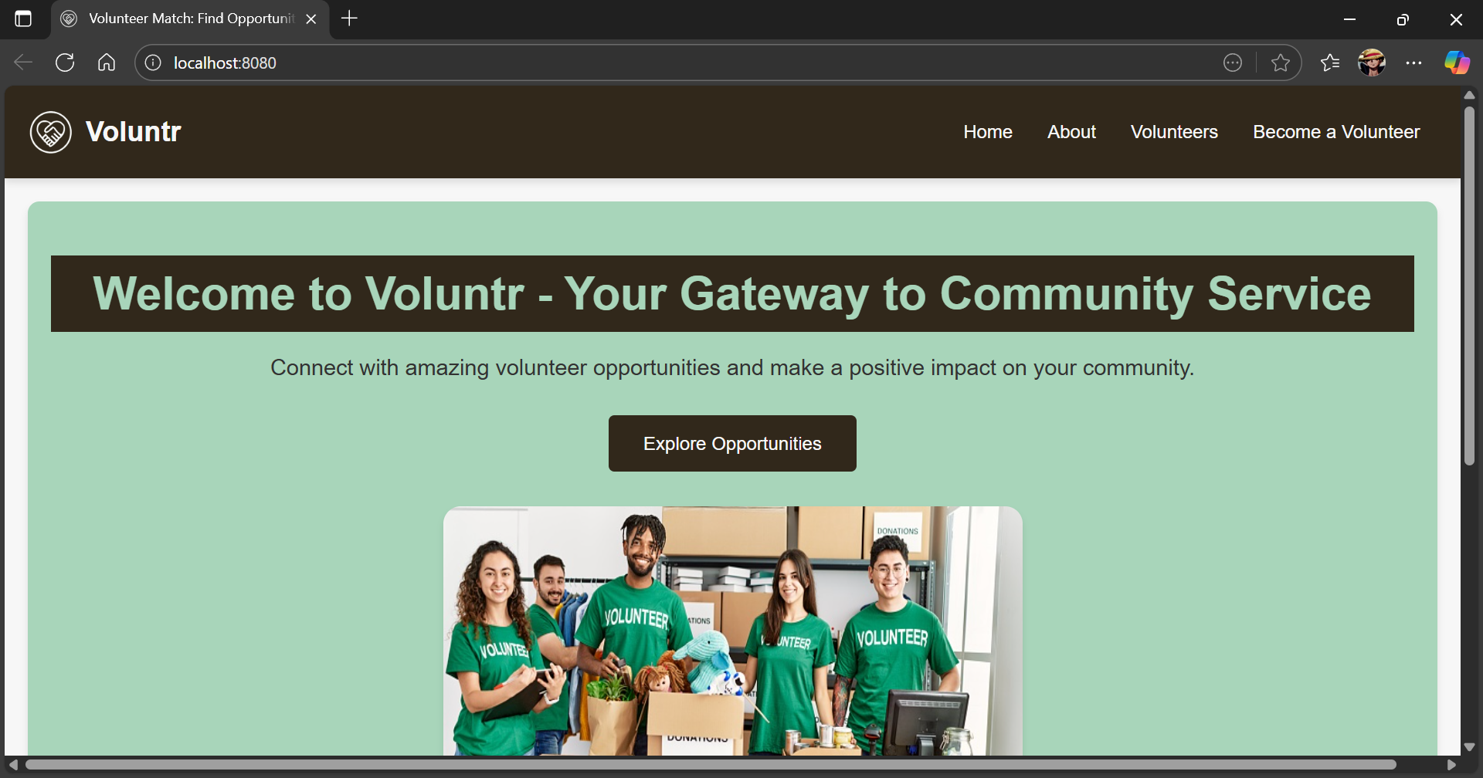
  - Push the image on Docker Hub.
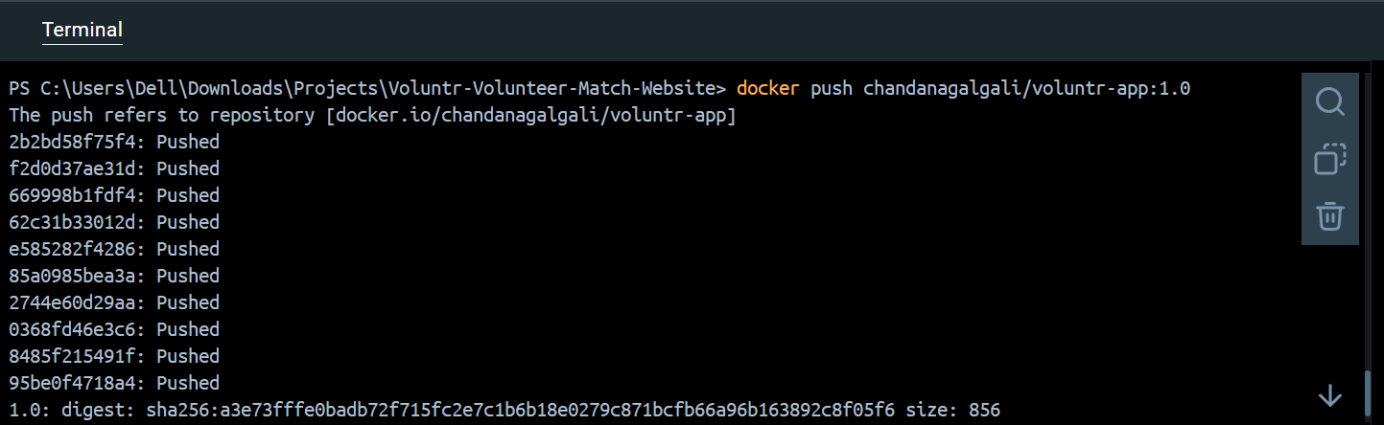
  - Deployment code for Kubernetes
apiVersion: apps/v1
kind: Deployment
metadata:
name: voluntr-app-deployment
labels:
app: voluntr-app
spec:
replicas: 2 # You can change this to 1 or more to control how many instances run.
selector:
matchLabels:
app: voluntr-app
template:
metadata:
labels:
app: voluntr-app
spec:
containers:
- name: voluntr-app-container
image: chandanagalgali/voluntr-app:1.0 # This is the image you built and pushed.
ports:
- containerPort: 80 # NGINX serves the website on this port.

apiVersion: v1
kind: Service
metadata:
name: voluntr-app-service
spec:
type: LoadBalancer # Exposes the service on a cloud provider's load balancer.
selector:
app: voluntr-app
ports:
- protocol: TCP
port: 80 # The port the service will be exposed on.
targetPort: 80 # The port the container is listening on.

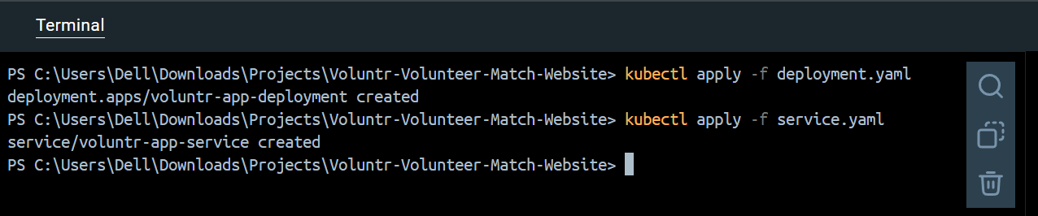
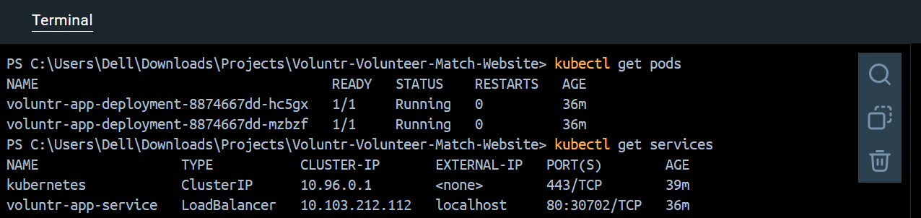
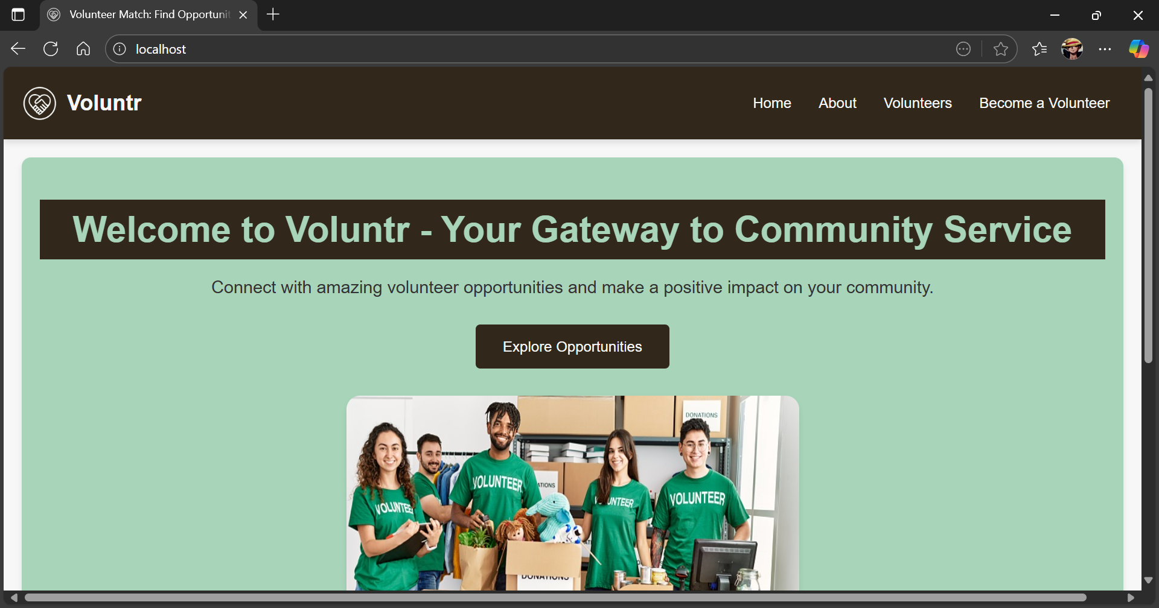
  - Running application
- Push Updated code and see the changes in running application
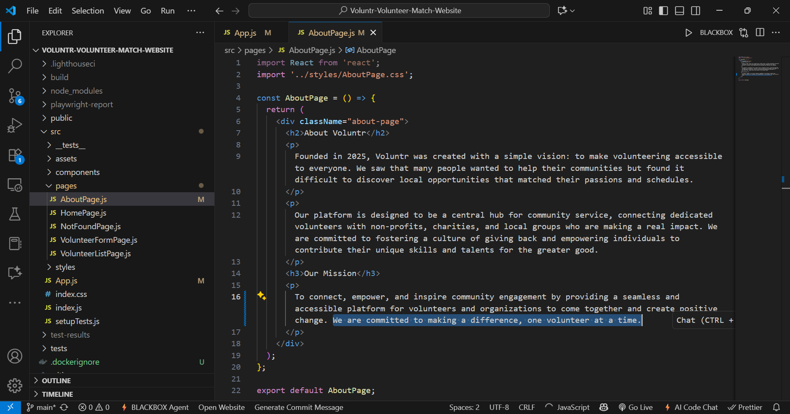
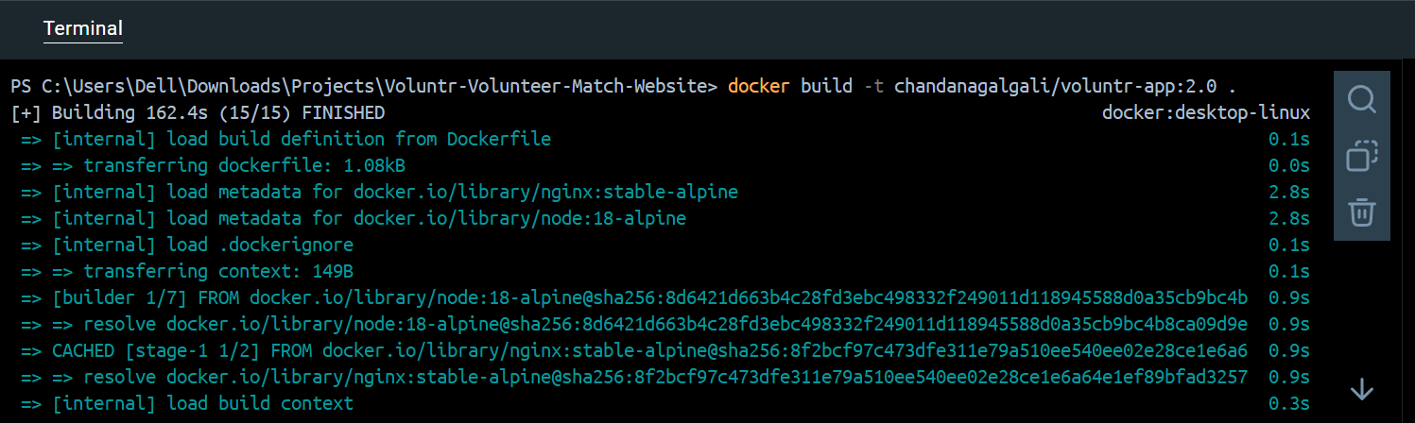
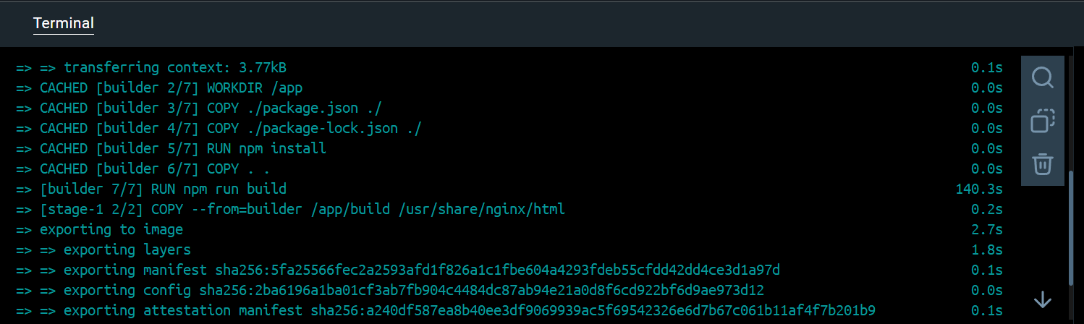
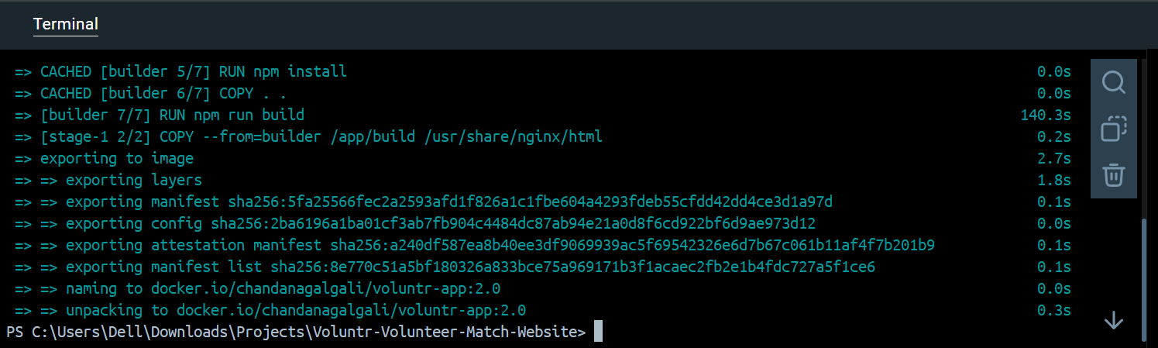
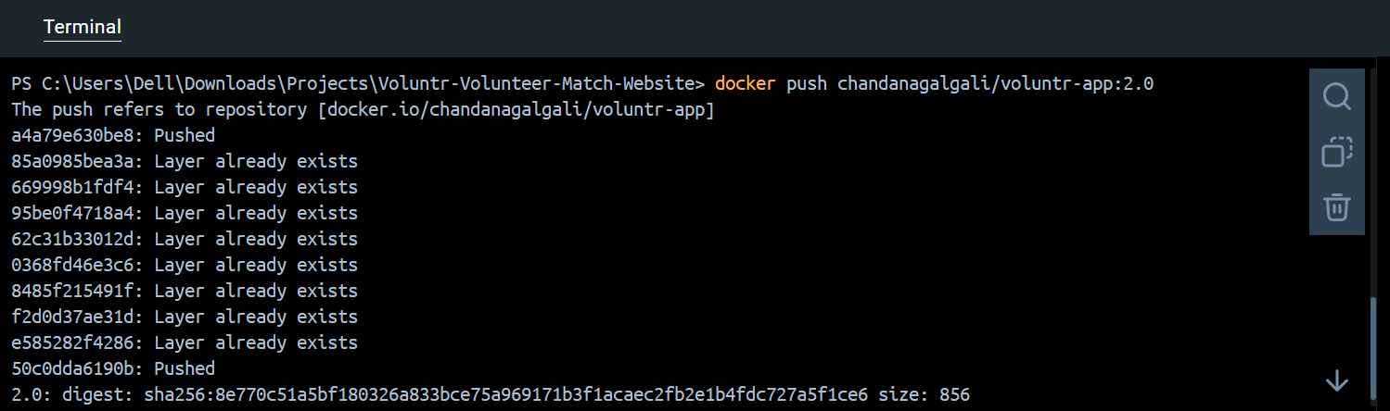
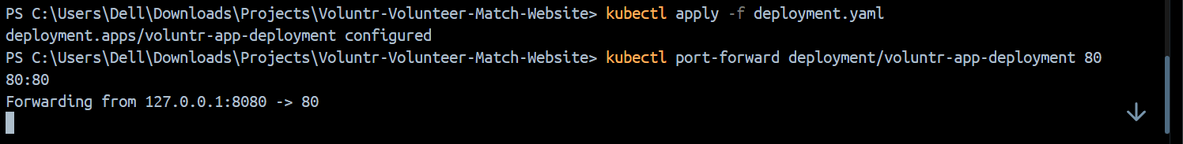

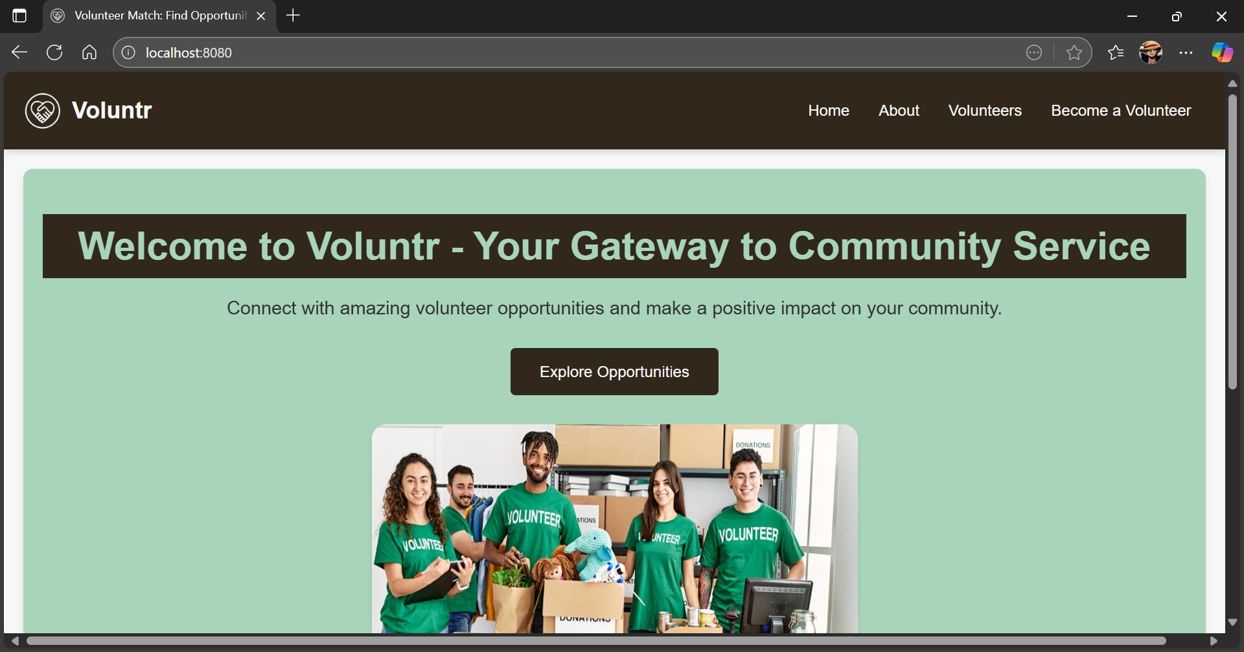
_____________________________________________________________________________

Questions:
- What is Docker file and Docker compose?
Ans: A Dockerfile is a text file that contains a set of instructions used to build a Docker image. Think of it as a blueprint for creating an image. These instructions specify everything needed to create a running container, including the base operating system, application code, dependencies, environment variables, and commands to execute when the container starts. Each instruction in a Dockerfile creates a layer in the Docker image, promoting efficiency and reusability. Docker Compose is a tool that allows you to define and run multi-container Docker applications. Instead of managing individual containers with separate docker run commands, Docker Compose uses a YAML file (typically docker-compose.yml) to configure all the services of your application. This file describes the services, networks, and volumes needed for your application, making it easy to start, stop, and rebuild the entire application stack with a single command. It simplifies the orchestration of complex applications composed of several interconnected services (e.g., a web application with a database and a caching service).

- Explain two containers other than Docker.
Ans: While Docker is the most widely known and used containerization technology, several other container runtimes and platforms offer similar functionalities. Here are two prominent examples:
I) Containerd:
- What it is: Containerd is an industry-standard core container runtime that manages the complete container lifecycle of a system. It's a daemon that manages container creation, execution, supervision, and destruction. Docker itself uses containerd under the hood to manage its containers.
- Key Features: It provides a client (CLI tool ctr) to interact with it, and handles image push/pull, storage, and network attachment for containers. Containerd focuses on simplicity, robustness, and portability. It's designed to be embedded into larger systems like Kubernetes.
- Analogy: If Docker is like a complete car that you can drive, containerd is the engine that makes the car move. It's a foundational component.
II) Podman:
- What it is: Podman (POD MANager) is a daemonless container engine for developing, managing, and running OCI (Open Container Initiative) containers on a Linux system. It's often seen as a direct alternative to Docker, offering a very similar command-line interface.
- Key Features: A significant difference from Docker is that Podman does not require a daemon to run, which can improve security. It can run containers as rootless, meaning they don't need elevated privileges. Podman is also compatible with Docker images and supports the same image formats. It's designed to be a drop-in replacement for Docker for many use cases, particularly in development and single-host deployments.
- Analogy: If Docker is a popular brand of a modular building toy set, Podman is another brand that uses the same interlocking pieces and offers a very similar building experience, sometimes with different benefits like not needing a central "master builder" (daemon).
_____________________________________________________________________________

Outcomes: CO4 – Explain code deployment and monitoring systems and their tool support.
_____________________________________________________________________________

Conclusion: (Conclusion to be based on the Results and outcomes achieved)
This experiment successfully demonstrated the end-to-end process of containerizing a NodeJS application using Docker. We began by creating a Dockerfile to define the build instructions, then used it to construct a Docker image. This image was subsequently run as a Docker container, verifying the application's functionality within an isolated environment. Finally, the image was pushed to Docker Hub for easy distribution and version control. The deployment of the Docker image to a Kubernetes cluster using a deployment and service further showcased how containerized applications can be orchestrated for scalability and management, and how updates to the code could be seamlessly deployed. This comprehensive procedure highlights the benefits of Docker and Kubernetes in streamlining application development, deployment, and management workflows.
_____________________________________________________________________________

Grade: AA / AB / BB / BC / CC / CD / DD

Signature of faculty in-charge with date
_____________________________________________________________________________

References:
Books/ Journals/ Websites:
- https://www.digitalocean.com/community/tutorials/how-to-install-and-use-docker-on- ubuntu-18-04
- https://www.simplilearn.com/tutorials/docker-tutorial/install-docker-on-windows
- https://www.simplilearn.com/tutorials/docker-tutorial/how-to-install-docker-on-ubuntu
- https://www.whitesourcesoftware.com/free-developer-tools/blog/docker-images-vs- docker-containers/
- Docker Commands Tutorial: https://www.edureka.co/blog/docker-commands/
- Docker Basic Commands | Docker Commands with Examples | Docker Commands Tutorial | Intellipaat: https://www.youtube.com/watch?v=nXV6qihj5uw
- https://www.simplilearn.com/tutorials/docker-tutorial/what-is-dockerfile
_____________________________________________________________________________

